# Extract Transform and Load Tutorial – ETL Data Quality and cleaning

# ETL – 1

This tutorial works with the insurance data sets S_0_DataSet1 and S_0_DataSet2 to support the reports such as: No of claims per year per location.

Each dataset represents data from insurance companies, one operates across multiple states in America the other is just from Washington (S_0_DataSet1 and S_0_DataSet2)

# ETL 1 – overview

In this first tutorial we will implement the data dictionary design. There is a template for this Data Dictionary 1.

This tutorial:

1. Load the raw data (data sets S_0_DataSet1 and S_0_DataSet2) into Apex
2. Explore the datasets and consider the data quality issues in each data set.
3. Identify the columns in each dataset that are required to support the report: No of claims per year per location.
4. EXTRACT: Create a dataset that contains JUST the data you need to work out how many claims per year per location from both data sets (call this S1_StageArea). You could have a number of these ‘stageing’ datasets)
5. Use code or tools, to find data quality issues with the data sets S1_StageArea*. Document these in the Data Dictionary using the Data Dictionary 1 template.*
6. Use code to clean (quality checks) S1_StageArea.
7. Consider the use of a table to log the changes made to the data.
8. Create the star schema model for the exercise in QSEE and create the DDL for the SS. It is good practice to prefix the star schema tables with SS.

# Suggested Solution –

# 1. ETL1_Claims_Merge_data

-- Extract just the data we need for report no_of_claims per year per location

-- explore

DESC S0_DATASET1

SELECT CUSTOMER, STATE, EFFECTIVE_TO_DATE, TOTAL_CLAIM_AMOUNT FROM S0_DATASET1;

DESC S0_DATASET2;

SELECT CUSTOMER, STATE, EFFECTIVE_TO_DATE, TOTAL_CLAIM_AMOUNT FROM S0_DATASET2;

-- put all into one table

-- the data columns are related so we can stack the data on top of each other

-- sometimes we would put it alongside - so many column, or bring over separate datasets

DROP TABLE S1_STAGEAREA;

CREATE TABLE S1_STAGEAREA AS SELECT CUSTOMER, STATE, EFFECTIVE_TO_DATE, TOTAL_CLAIM_AMOUNT FROM S0_DATASET1;

-- I'm going to add a column to show where the data has come from

ALTER TABLE S1_STAGEAREA

ADD DATASOURCE VARCHAR2(5);

UPDATE S1_STAGEAREA SET DATASOURCE = 'DS1';

INSERT INTO S1_STAGEAREA (SELECT CUSTOMER, STATE, EFFECTIVE_TO_DATE, TOTAL_CLAIM_AMOUNT, 'DS2' FROM S0_DATASET2);

# 2. ETL1_Claims_transforms

-- Data Quality checks and transformation on S1_STAGEAREA

-- Quality Check example -

-- Update the data, maybe set it to ‘not known’, or maybe delete it?

-- This is the code we want to do - don't run it just yet

UPDATE S1_STAGEAREA

SET state = 'not known'

WHERE

state IS NULL

OR state = ''

OR state = '-';

Consider the use of a table to log the changes made to the data,

Should we log the changes we have made? We have a data dictionary.

If so we could use a trigger and a ‘ETL_log’ table.

Solution:

-- log ETL changes

DROP table etl_log cascade constraints;

CREATE TABLE etl_log

(issue_id NUMBER(5) NOT NULL,

table_name VARCHAR2(20),

data_error_code NUMBER(5),

issue_desc VARCHAR2(50),

issue_date DATE,

issue_status VARCHAR2(20),

status_update_date DATE);

drop sequence EL_SEQ;

create sequence EL_SEQ

start with 1

increment by 1

maxvalue 10000

minvalue 1;

-- Now as part of the ETL - T for transformation, we will do data quality checks and log them in a data issues table

-- we have decided to update S1_STAGEAREA directly.

DROP TRIGGER S1_stagearea.trg_quality_chk ;

-- START of data transformations

CREATE or REPLACE trigger trg_quality_chk

before update on S1_STAGEAREA

for each row

begin

INSERT INTO ETL_log

(issue_id, table_name, data_error_code, issue_desc, issue_date, issue_status, status_update_date)

VALUES

(EL_SEQ.nextval, 'S1_STAGEAREA', '0', 'Quality checks', SYSDATE, 'completed', SYSDATE);

end;

-- Quality Check

UPDATE S1_STAGEAREA SET state = 'NOT KNOWN' WHERE state IS NULL;

-- Transformation (or Quality Check?)

UPDATE S1_STAGEAREA SET state = 'Washington' WHERE state ='WA';

-- the dates are a mess

DELETE FROM S1_STAGEAREA WHERE effective_to_date IS NULL;

-- we only want the years so (this is not entirely correct but will do for now)

-- Transform dates into just the year

DROP TABLE S2_STAGEAREA;

CREATE TABLE S2_STAGEAREA AS SELECT CUSTOMER, STATE, EFFECTIVE_TO_DATE, TOTAL_CLAIM_AMOUNT, DATASOURCE FROM S1_STAGEAREA;

DELETE FROM S2_STAGEAREA;

INSERT INTO S2_STAGEAREA (SELECT CUSTOMER, STATE, '2011', TOTAL_CLAIM_AMOUNT, DATASOURCE FROM S1_STAGEAREA WHERE effective_to_date LIKE '%11');

INSERT INTO S2_STAGEAREA (SELECT CUSTOMER, STATE, '2012', TOTAL_CLAIM_AMOUNT, DATASOURCE FROM S1_STAGEAREA WHERE effective_to_date LIKE '%12');

INSERT INTO S2_STAGEAREA (SELECT CUSTOMER, STATE, '2010', TOTAL_CLAIM_AMOUNT, DATASOURCE FROM S1_STAGEAREA WHERE effective_to_date LIKE '%10');

INSERT INTO S2_STAGEAREA (SELECT CUSTOMER, STATE, '1960', TOTAL_CLAIM_AMOUNT, DATASOURCE FROM S1_STAGEAREA WHERE effective_to_date LIKE '%60');

SELECT * FROM S2_STAGEAREA

SELECT * FROM etl_log;

# Create the star schema model for the exercise in QSEE and creates the DDL for the SS.

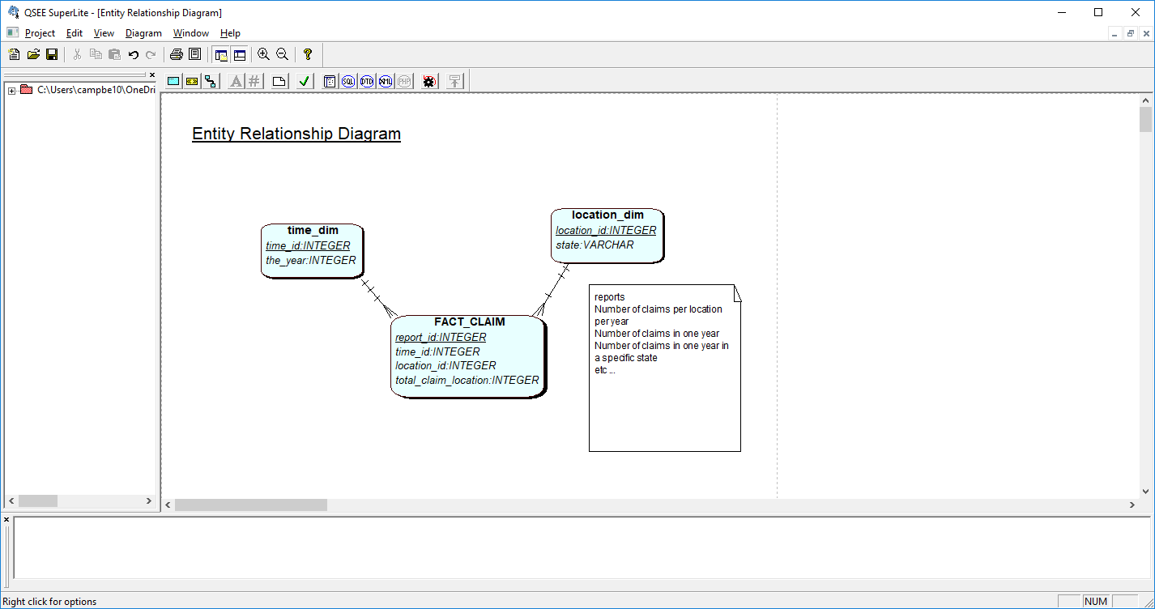

Use QSEE to create the above. Click on SQL button, change the generated script as you need to. (It needs changing!)

ETl 1 - Solution of DDL:

--------------------------------------------------------------

-- Database creation Script

-- Auto-Generated by QSEE-SuperLite (c) 2001-2004 QSEE-Technologies Ltd.

-- Verbose generation: ON

-- note: spaces within table/column names have been replaced by underscores (_)

-- Target DB: SQL2

-- Entity Model :Entity Relationship Diagram

--------------------------------------------------------------

DROP table time_dim cascade constraints;

DROP table location_dim cascade constraints;

DROP table fact_claim cascade constraints;

--------------------------------------------------------------

-- Table Creation --

-- Each entity on the model is represented by a table that needs to be created within the Database.

-- Within SQL new tables are created using the CREATE TABLE command.

-- When a table is created its name and its attributes are defined.

-- The values of which are derived from those specified on the model.

-- Certain constraints are sometimes also specified, such as identification of primary keys.

-- Create a Database table to represent the "FACT_CLAIM" entity.

CREATE TABLE FACT_CLAIM(

report_id INTEGER NOT NULL,

fk1_time_id INTEGER NOT NULL,

fk2_location_id INTEGER NOT NULL,

total_claim_location INTEGER,

-- Specify the PRIMARY KEY constraint for table "FACT_CLAIM".

-- This indicates which attribute(s) uniquely identify each row of data.

CONSTRAINT pk_FACT_CLAIM PRIMARY KEY (report_id)

);

-- Create a Database table to represent the "time_dim" entity.

CREATE TABLE time_dim(

time_id INTEGER NOT NULL,

the_year INTEGER,

-- Specify the PRIMARY KEY constraint for table "time_dim".

-- This indicates which attribute(s) uniquely identify each row of data.

CONSTRAINT pk_time_dim PRIMARY KEY (time_id)

);

-- Create a Database table to represent the "location_dim" entity.

CREATE TABLE location_dim(

location_id INTEGER NOT NULL,

state VARCHAR(10),

-- Specify the PRIMARY KEY constraint for table "location_dim".

-- This indicates which attribute(s) uniquely identify each row of data.

CONSTRAINT pk_location_dim PRIMARY KEY (location_id)

);

--------------------------------------------------------------

-- Alter Tables to add fk constraints –

# 3. ETL1_Claims_load

-- Populate the Dimension tables

-- Populate the fact table

-- first run the SS claims script to create the dimension and fact table

-- Now to populate the time_dim

DROP sequence time_seq;

create sequence time_SEQ

start with 1

increment by 1

maxvalue 10000

minvalue 1;

INSERT INTO time_dim VALUES( time_seq.nextval, '2011');

INSERT INTO time_dim VALUES( time_seq.nextval, '2010');

INSERT INTO time_dim VALUES( time_seq.nextval, '2012');

INSERT INTO time_dim VALUES( time_seq.nextval, '1960');

-- Now repeat similar for the location dimension table

--

DROP table tmp_locations;

Create table tmp_locations as SELECT DISTINCT state FROM S2_STAGEAREA;

DROP sequence loc_seq;

create sequence loc_SEQ

start with 1

increment by 1

maxvalue 10000

minvalue 1;

INSERT INTO location_dim SELECT loc_seq.nextval, state FROM tmp_locations;

-- Or use straight forward code as below

-- INSERT INTO location_dim VALUES (1, 'WA');

-- Populates the Fact table from the cleaned data sets

-- the report in sum of the claims per year

-- Coding approaches are discussed and evaluated

-- Solutions:

-- Option1: Create a detail table, then select from this.

-- Option2: Create a cart-prod of ids from time and location and then update on the fact table.

-- Option1 – solution as below

-- The fact_claims table

DROP sequence fact_seq;

create sequence FACT_SEQ

start with 1

increment by 1

maxvalue 10000

minvalue 1;

DROP table tmp_claim1;

-- this tmp table contains all data we need, with the year (not the whole date)

CREATE TABLE tmp_claim1 AS SELECT state, total_claim_amount, effective_to_date as which_year

FROM S2_STAGEAREA;

DROP table tmp_claim2;

-- This tmp table contains the sum of the claim by year and state

CREATE TABLE tmp_claim2 AS

SELECT which_year, state, SUM(total_claim_amount) as claim_amount FROM tmp_claim1

GROUP BY which_year, state;

-- check the data

SELECT * FROM tmp_claim2;

SELECT * FROM time_dim;

SELECT * FROM location_dim;

INSERT INTO FACT_claim (report_id, fk1_time_id, fk2_location_id , total_claim_location)

SELECT fact_seq.nextval, time_dim.time_id, location_dim.location_id, tmp_claim2.claim_amount

FROM tmp_claim2, time_dim, location_dim

WHERE tmp_claim2.which_year = time_dim.the_year AND tmp_claim2.state = location_dim.state;

-- Over to you to check run as reports

SELECT * FROM fact_claim

Lastly consider how data can be extracted from the SS tables and pulled into a visualisation tool, as we did with Excel.